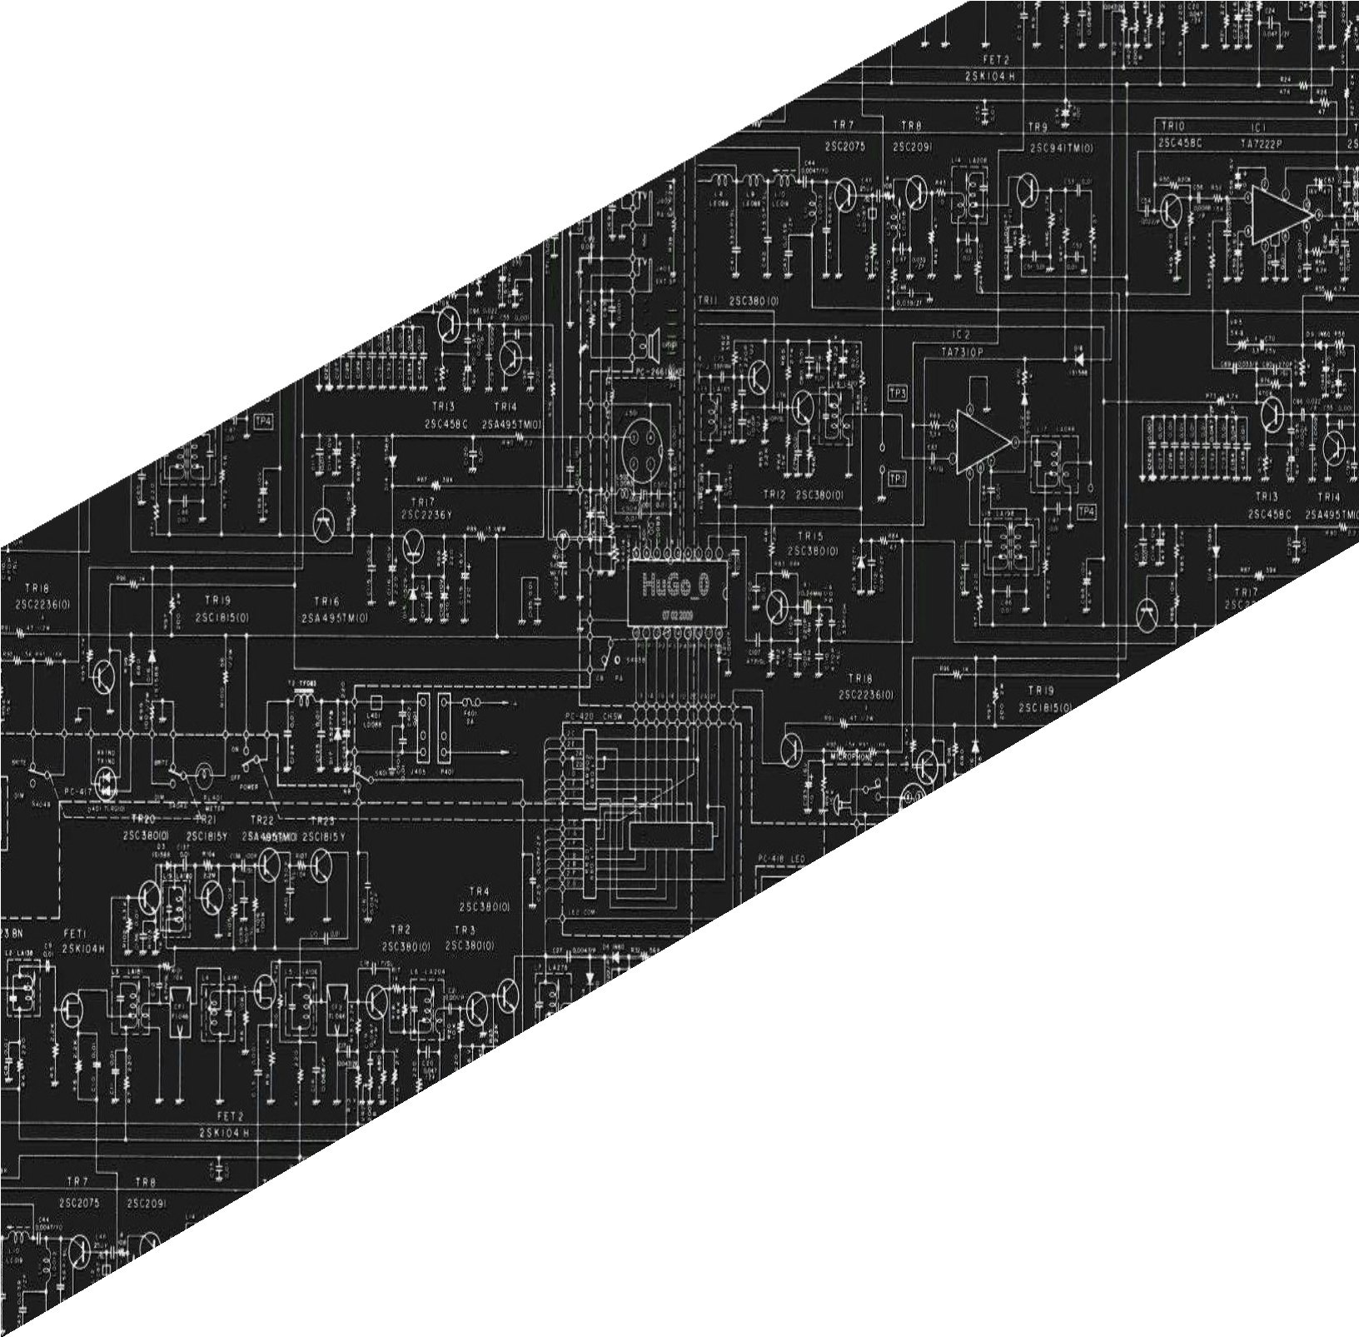

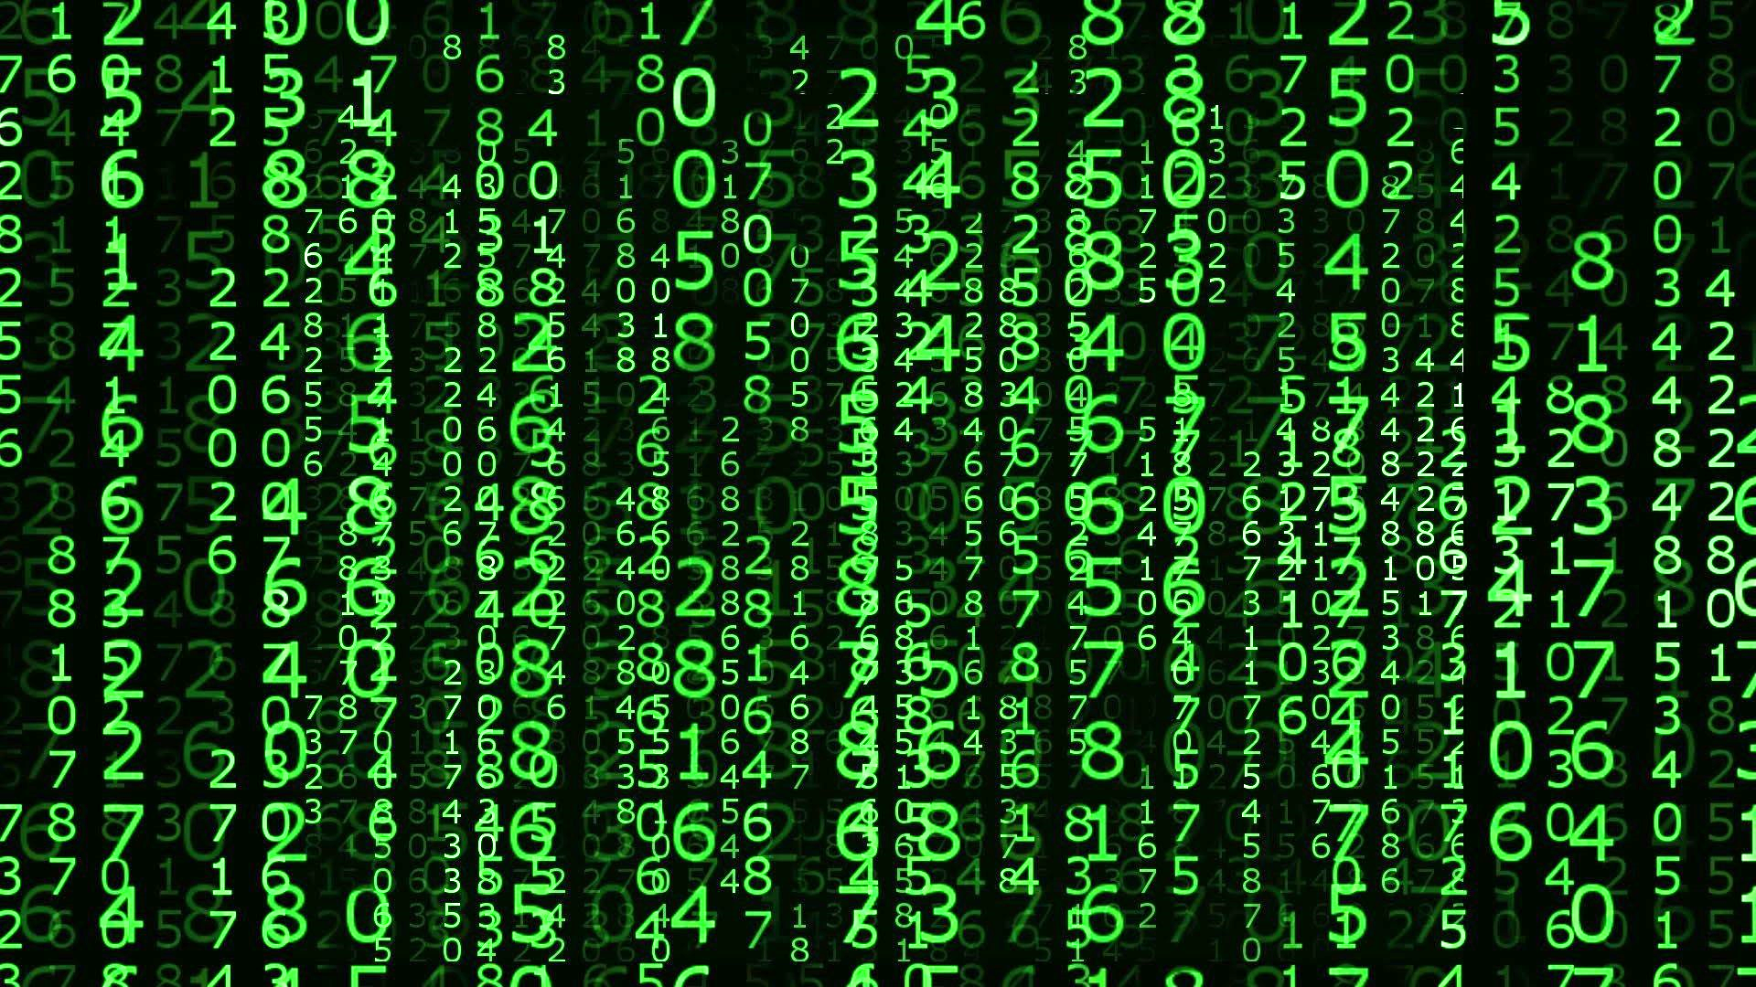

**PANGASINAN STATE UNIVERSITY**

URDANETA CITY CAMPUS

SECOND SEMESTER, AY 2021-2022

LABORATORY

REPORT

CpE222 SOFTWARE DESIGN

**SUBMITTED BY**

**Lendl Johnfil M. Claro**

**SUBMITTED TO**

**Engr. Jay-Ar M. Pentecostes**

**Laboratory Activity 03**

**Software Design Laboratory**

**Content:**

**1. PreLab**

* **Readings**

**1.1 Python DS**:

* Chapters 7 ,8 ,10 ,12 : Ref Lab3 Fundamentals Of Python Data

Structures , Kenneth A. Lambert

**Write your own Observation and Conclusion from what you have read.**

**Stacks**

Stacks are linear collections in which access is completely restricted to just one end, called the top. The classic analogous example is the stack of clean trays found in every cafeteria. Whenever a tray is needed, it is removed from the top of the stack, and whenever clean ones come back from the kitchen, they are again placed on the top. No one ever takes some particularly fine tray from the middle of the stack, and trays near the bottom might never be used. Stacks are said to adhere to a last-in first-out (LIFO) protocol. The last tray brought back from the dishwasher is the first one a customer takes.

A stack is a linear collection that allows access to one end only, called the top. Elements are pushed onto the top or popped from it. Other operations on stacks include peeking at the top element, determining the number of elements, determining whether the stack is empty, and returning a string representation. Stacks are used in applications that manage data items in a last-in first-out manner. These applications include matching bracket symbols in expressions, evaluating postfix expressions, backtracking algorithms, and managing memory for subroutine calls on a virtual machine. Arrays and singly linked structures support simple implementations of stacks.

**Queues**

Like stacks, queues are linear collections. However, with queues, insertions are restricted to one end, called the rear, and removals to the other end, called the front. A queue thus supports a first-in first-out (FIFO) protocol. Queues are omnipresent in everyday life and occur in any situation where people or things are lined up for service or processing on a first-come, first-served basis. Checkout lines in stores, highway tollbooth lines, and airport baggage check-in lines are familiar examples of queues. Queues have two fundamental operations: add, which adds an item to the rear of a queue, and pop, which removes an item from the front. Figure 8-1 shows a queue as it might appear at various stages in its lifetime. In the figure, the queue’s front is on the left, and its rear is on the right.

A queue is a linear collection that adds elements to one end, called the rear, and removes them from the other end, called the front. Thus, they are accessed in first-in first-out (FIFO) order.

Queues are used in applications that manage data items in a FIFO order. These applications include scheduling items for processing or access to resources. Arrays and singly linked structures support simple implementations of queues. Priority queues schedule their elements using a rating scheme as well as a FIFO order. If two elements have equal priority, they are scheduled in FIFO order. Otherwise, elements are ranked from smallest to largest, according to some attribute, such as a number or an alphabetical content. In general, elements with the smallest priority values are removed first, no matter when they are added to the priority queue.

**Trees**

Trees are hierarchical collections. The topmost node in a tree is called its root. In a general tree, each node below the root has at most one predecessor, or parent node, and zero or more successors, or child nodes. Nodes without children are called leaves. Nodes that have children are called interior nodes. The root of a tree is at level 0, its children are at level 1, and so on. In a binary tree, a node can have at most two children. A complete binary tree fills each level of nodes before moving to the next level. A full binary tree includes all the possible nodes at each level.

There are four standard types of tree traversals: preorder, inorder, postorder, and level order.

An expression tree is a type of binary tree in which the interior nodes contain operators and the successor nodes contain their operands. Atomic operands are contained in the leaf nodes. Expression trees represent the structure of expressions in programming language parsers and interpreters. A binary search tree is a type of binary tree in which each nonempty left subtree contains data that are less than the datum in its parent node, and each nonempty right subtree contains data that are greater than the datum in its parent node. A binary search tree supports logarithmic searches and insertions if it is close to complete. A heap is a type of binary tree in which smaller data items are located near the root. You can use a heap to implement the n log n heap sort algorithm and a priority queue.

**Graphs**

Graphs have many applications. They are often used to represent networks of items that can be connected by various paths. A graph consists of one or more vertices (items) connected by one or more edges. One vertex is adjacent to another vertex if there is an edge connecting the two vertices. These two vertices are also called neighbors. A path is a sequence of edges that allows one vertex to be reached from another vertex in the graph. A vertex is reachable from another vertex if and only if there is a path between the two. The length of a path is the number of edges in the path. A graph is connected if there is a path from each vertex to every other vertex. A graph is complete if there is an edge from each vertex to every other vertex.

A subgraph consists of a subset of a graph’s vertices and a subset of its edges. A connected component is a subgraph consisting of the set of vertices that are reachable from a given vertex. Directed graphs allow travel along an edge in just one direction, whereas undirected graphs allow two-way travel. Edges can be labeled with weights, which indicate the cost of traveling along them. Graphs have two common implementations. An adjacency matrix implementation of a graph with N vertices uses a two-dimensional grid G with N rows and N columns. The cell G[i][j] contains 1 if there is an edge from vertex i to vertex j in the graph. Otherwise, there is no edge, and that cell contains 0.

**1.2 Python DS**: Chapters 7, 10 : Ref Lab3 Data Structures and

Algorithms in Python Michael T. Goodrich, Roberto Tamassia et.al

**Write your own Observation and Conclusion from what you have read.**

Linked List

A singly linked list, in its simplest form, is a collection of nodes that collectively form a linear sequence. Each node stores a reference to an object that is an element of the sequence, as well as a reference to the next node of the list. In the case of linked lists, there is a more tangible notion of a circularly linked list, as we can have the tail of the list use its next reference to point back to the head of the list. We call such a structure a circularly linked list. we develop an implementation that operates on a PositionalList, relying on the same high-level algorithm in which each element is placed relative to a growing collection of previously sorted elements. We maintain a variable named marker that represents the rightmost position of the currently sorted portion of a list. During each pass, we consider the position just past the marker as the pivot and consider where the pivot’s element belongs relative to the sorted portion; we use another variable, named walk, to move leftward from the marker, as long as there remains a preceding element with value larger than the pivot’s.

Maps, Hash Tables, and Skip Lists

Python’s dict class is arguably the most significant data structure in the language. It represents an abstraction known as a dictionary in which unique keys are mapped to associated values. Because of the relationship they express between keys and values, dictionaries are commonly known as associative arrays or maps. In this book, we use the term dictionary when specifically discussing Python’s dict class, and the term map when discussing the more general notion of the abstract data type.

The MutableMapping abstract base class, from Python’s collections module and discussed in the preceding pages, is a valuable tool when implementing a map. However, in the interest of greater code reuse, we define our own MapBase class, which is itself a subclass of the MutableMapping class.

We introduce one of the most practical data structures for implementing a map, and the one that is used by Python’s own implementation of the dict class. This structure is known as a hash table. The first action that a hash function performs is to take an arbitrary key k in our map and compute an integer that is called the hash code for k; this integer need not be in the range [0,N −1], and may even be negative. We desire that the set of hash codes assigned to our keys should avoid collisions as much as possible. For if the hash codes of our keys cause collisions, then there is no hope for our compression function to avoid them. In this subsection, we begin by discussing the theory of hash codes. The hash code for a key k will typically not be suitable for immediate use with a bucket array, because the integer hash code may be negative or may exceed the capacity of the bucket array. Thus, once we have determined an integer hash code for a key object k, there is still the issue of mapping that integer into the range [0,N −1]. This computation, known as a compression function, is the second action performed as part of an overall hash function. A good compression function is one that minimizes the number of collisions for a given set of distinct hash codes.

Sets Although sets and maps have very different public interfaces, they are really quite similar. A set is simply a map in which keys do not have associated values. Any data structure used to implement a map can be modified to implement the set ADT with similar performance guarantees. We could trivially adapt any map class by storing set elements as keys, and using None as an irrelevant value, but such an implementation is unnecessarily wasteful. An efficient set implementation should abandon the Item composite that we use in our MapBase class and instead store set elements directly in a data structure. Multisets The same element may occur several times in a multiset. All of the data structures we have seen can be reimplemented to allow for duplicates to appear as separate elements. However, another way to implement a multiset is by using a map in which the map key is a (distinct) element of the multiset, and the associated value is a count of the number of occurrences of that element within the multiset.

Formally, the Counter class is a subclass of dict, with the expectation that values are integers, and with additional functionality like a most common(n) method that returns a list of the n most common elements. The standard iter reports each element only once (since those are formally the keys of the dictionary). There is another method named elements( ) that iterates through the multiset with each element being repeated according to its count. Multimaps Although there is no multimap in Python’s standard libraries, a common implementation approach is to use a standard map in which the value associated with a key is itself a container class storing any number of associated values.

* **Answers to Questions**

Ref Lab3 Data Structures and Algorithms in Python Michael T. Goodrich,

Roberto Tamassia et.al

**Answer : R-7.1 to R-7.4 page 294**

R-7.1 Give an algorithm for finding the second-to-last node in a singly linked list in which the last node is indicated by a next reference of None.

class Node:  
 def __init__(self, data):  
 self.data = data  
 self.next = None  
  
def findSecondLastNode(head):  
 temp = head  
  
 if (temp == None or temp.next == None):  
 return -1  
  
 while (temp != None):  
 if (temp.next.next == None):  
 return temp.data  
 temp = temp.next  
  
def push(head, new_data):  
 new_node = Node(new_data)  
 new_node.next = head  
 head = new_node  
 return head  
  
if __name__ == '__main__':  
 head = None  
 head = push(head, 12)  
 head = push(head, 29)  
 head = push(head, 11)  
 head = push(head, 23)  
 head = push(head, 8)  
  
 print(findSecondLastNode(head))

R-7.2 Describe a good algorithm for concatenating two singly linked lists L and M, given only references to the first node of each list, into a single list L that contains all the nodes of L followed by all the nodes of M.

Algorithm concatenate(L,M): Node n ⇓ L.getHead() While (n.getNext()!=null)do n ⇓ n.getNext() n.setNext(M.getHead()) L’ ⇓ L

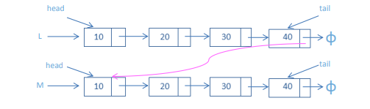

R-7.3 Describe a recursive algorithm that counts the number of nodes in a singly linked list.

class Node:  
 def __init__(self, data):  
 self.data = data  
 self.next = None  
  
class SinglyList:  
 def __init__(self):  
 self.head = None  
  
 def push(self, new_data):  
 new_node = Node(new_data)  
 new_node.next = self.head  
 self.head = new_node  
  
 def getCount(self):  
 temp = self.head  
 count = 0  
 while (temp):  
 count += 1  
 temp = temp.next  
 return count  
  
if __name__ == '__main__':  
 llist = SinglyList()  
 llist.push(1)  
 llist.push(3)  
 llist.push(1)  
 llist.push(2)  
 llist.push(1)  
 print("Count of nodes is :", llist.getCount())

R-7.4 Describe in detail how to swap two nodes x and y (and not just their contents) in a singly linked list L given references only to x and y. Repeat this exercise for the case when L is a doubly linked list. Which algorithm takes more time?

class LinkedList(object):  
 def __init__(self):  
 self.head = None  
  
 class Node(object):  
 def __init__(self, d):  
 self.data = d  
 self.next = None  
  
 def swapNodes(self, x, y):  
 if x == y:  
 return  
  
 prevX = None  
 currX = self.head  
 while currX != None and currX.data != x:  
 prevX = currX  
 currX = currX.next  
  
 prevY = None  
 currY = self.head  
 while currY != None and currY.data != y:  
 prevY = currY  
 currY = currY.next  
   
 if currX == None or currY == None:  
 return  
 if prevX != None:  
 prevX.next = currY  
 else:  
 self.head = currY  
 if prevY != None:  
 prevY.next = currX  
 else:  
 self.head = currX  
  
 temp = currX.next  
 currX.next = currY.next  
 currY.next = temp  
  
 def push(self, new_data):  
 new_Node = self.Node(new_data)  
 new_Node.next = self.head  
 self.head = new_Node  
   
 def printList(self):  
 tNode = self.head  
 while tNode != None:  
 print(tNode.data),  
 tNode = tNode.next  
  
  
if __name__ == '__main__':  
 llist = LinkedList()  
 llist.push(7)  
 llist.push(6)  
 llist.push(5)  
 llist.push(4)  
 llist.push(3)  
 llist.push(2)  
 llist.push(1)  
 print("Linked list before calling swapNodes()")  
 llist.printList()  
 llist.swapNodes(4, 3)  
 print("\nLinked list after calling swapNodes()")  
 llist.printList()

**2. InLab**

* Write your Objectives (you can have your own objectives)
* To know the usage of these given topics
* To have a knowledge of using list, stack, queue, binary search and so on.

Implementation of Single / Circular / Doubly Linked List

* 1. Write Python programs for the following operations on Single / Circular / Doubly Linked List.

(i) Creation (ii) insertion (iii) deletion (iv) traversal

class Node:  
 def __init__(self, data):  
 self.data = data  
 self.next = None  
  
class LinkedList:  
 def __init__(self):  
 self.head = None  
  
 def insertAtBeginning(self, new_data):  
 new_node = Node(new_data)  
 new_node.next = self.head  
 self.head = new_node  
  
 def insertAfter(self, prev_node, new_data):  
 if prev_node is None:  
 print("The given previous node must inLinkedList.")  
 return  
 new_node = Node(new_data)  
 new_node.next = prev_node.next  
 prev_node.next = new_node  
  
 def insertAtEnd(self, new_data):  
 new_node = Node(new_data)  
  
 if self.head is None:  
 self.head = new_node  
 return  
 last = self.head  
 while (last.next):  
 last = last.next  
  
 last.next = new_node  
  
 def deleteNode(self, position):  
  
 if self.head is None:  
 return  
 temp = self.head  
 if position == 0:  
 self.head = temp.next  
 temp = None  
 return  
 for i in range(position - 1):  
 temp = temp.next  
 if temp is None:  
 break  
 if temp is None:  
 return  
 if temp.next is None:  
 return  
 next = temp.next.next  
 temp.next = None  
 temp.next = next  
  
 def search(self, key):  
 current = self.head  
 while current is not None:  
 if current.data == key:  
 return True  
 current = current.next  
 return False  
  
 def sortLinkedList(self, head):  
 current = head  
 index = Node(None)  
 if head is None:  
 return  
 else:  
 while current is not None:  
 index = current.next  
  
 while index is not None:  
 if current.data > index.data:  
 current.data, index.data = index.data, current.data  
 index = index.next  
 current = current.next  
  
 def printList(self):  
 temp = self.head  
 while (temp):  
 print(str(temp.data) + " ", end="")  
 temp = temp.next  
  
if __name__ == '__main__':  
 llist = LinkedList()  
 llist.insertAtEnd(1)  
 llist.insertAtBeginning(2)  
 llist.insertAtBeginning(3)  
 llist.insertAtEnd(4)  
 llist.insertAfter(llist.head.next, 5)  
 print('linked list:')  
 llist.printList()  
 print("\nAfter deleting an element:")  
 llist.deleteNode(3)  
 llist.printList()  
 print()  
 item_to_find = 3  
 if llist.search(item_to_find):  
 print(str(item_to_find) + " is found")  
 else:  
 print(str(item_to_find) + " is not found")  
 llist.sortLinkedList(llist.head)  
 print("Sorted List: ")  
 llist.printList()

* 1. To store a polynomial expression in memory using Single / Circular / Doubly Linked List.

class Node:  
 def __init__(self):  
 self.coeff = None  
 self.power = None  
 self.next = None  
  
def addnode(start, coeff, power):  
 newnode = Node();  
 newnode.coeff = coeff;  
 newnode.power = power;  
 newnode.next = None;  
 if (start == None):  
 return newnode;  
 ptr = start;  
 while (ptr.next != None):  
 ptr = ptr.next;  
 ptr.next = newnode;  
 return start;  
  
def printList(ptr):  
 while (ptr.next != None):  
 print(str(ptr.coeff) + 'x^' + str(ptr.power), end='')  
 if (ptr.next != None and ptr.next.coeff >= 0):  
 print('+', end='')  
 ptr = ptr.next  
 print(ptr.coeff)  
   
def removeDuplicates(start):  
 ptr2 = None  
 dup = None  
 ptr1 = start;  
 while (ptr1 != None and ptr1.next != None):  
 ptr2 = ptr1;  
 while (ptr2.next != None):  
 if (ptr1.power == ptr2.next.power):  
 ptr1.coeff = ptr1.coeff + ptr2.next.coeff;  
 dup = ptr2.next;  
 ptr2.next = ptr2.next.next;  
 else:  
 ptr2 = ptr2.next;  
 ptr1 = ptr1.next;  
  
def multiply(poly1, Npoly2, poly3):  
 ptr1 = poly1;  
 ptr2 = poly2;  
  
 while (ptr1 != None):  
 while (ptr2 != None):  
 coeff = ptr1.coeff * ptr2.coeff;  
 power = ptr1.power + ptr2.power;  
 poly3 = addnode(poly3, coeff, power);  
 ptr2 = ptr2.next;  
 ptr2 = poly2;  
 ptr1 = ptr1.next;  
 removeDuplicates(poly3);  
 return poly3;  
  
if __name__ == '__main__':  
 poly1 = None  
 poly2 = None  
 poly3 = None;  
  
 poly1 = addnode(poly1, 3, 3);  
 poly1 = addnode(poly1, 6, 1);  
 poly1 = addnode(poly1, -9, 0);  
 poly2 = addnode(poly2, 9, 3);  
 poly2 = addnode(poly2, -8, 2);  
 poly2 = addnode(poly2, 7, 1);  
 poly2 = addnode(poly2, 2, 0);  
  
 print("1st Polynomial:- ", end='');  
 printList(poly1);  
  
 print("2nd Polynomial:- ", end='');  
 printList(poly2);  
  
 poly3 = multiply(poly1, poly2, poly3);  
  
 print("Resultant Polynomial:- ", end='');  
 printList(poly3);

Implementation of Stack and Queue

* 1. Design and implement Stack and its operations using List.

class stack:  
 def __init__(self):  
 self.array = []  
 self.top = -1  
 self.max = 100  
  
 def isEmpty(self):  
  
 if self.top == -1:  
 return True  
 else:  
 return False  
  
 def isFull(self):  
  
 if self.top == self.max - 1:  
 return True  
 else:  
 return False  
  
 def push(self, data):  
 if self.isFull():  
 print('Stack OverFlow')  
 return  
 else:  
 self.top += 1  
 self.array.append(data)  
  
 def pop(self):  
  
 if self.isEmpty():  
 print('Stack UnderFlow')  
 return  
 else:  
 self.top -= 1  
 return self.array.pop()  
  
class SpecialStack(stack):  
  
 def __init__(self):  
 super().__init__()  
 self.Min = stack()  
  
 def push(self, x):  
 if self.isEmpty():  
 super().push(x)  
 self.Min.push(x)  
 else:  
 super().push(x)  
 y = self.Min.pop()  
 self.Min.push(y)  
 if x <= y:  
 self.Min.push(x)  
 else:  
 self.Min.push(y)  
  
 def pop(self):  
 x = super().pop()  
 self.Min.pop()  
 return x  
  
 def getmin(self):  
 x = self.Min.pop()  
 self.Min.push(x)  
 return x  
  
if __name__ == '__main__':  
 s = SpecialStack()  
 s.push(10)  
 s.push(20)  
 s.push(30)  
 print(s.getmin())  
 s.push(5)  
 print(s.getmin())

* 1. Design and implement Queue and its operations using List

class Queue:  
  
 def __init__(self):  
 self.queue = []  
  
 def enqueue(self, item):  
 self.queue.append(item)  
  
 def dequeue(self):  
 if len(self.queue) < 1:  
 return None  
 return self.queue.pop(0)  
  
 def display(self):  
 print(self.queue)  
  
 def size(self):  
 return len(self.queue)  
  
  
q = Queue()  
q.enqueue(1)  
q.enqueue(2)  
q.enqueue(3)  
q.enqueue(4)  
q.enqueue(5)  
  
q.display()  
  
q.dequeue()  
  
print("After removing an element")  
q.display()

Implementation of Binary Search Tree

* 1. Create a binary search tree.

class Node:  
 def __init__(self, key):  
 self.left = None  
 self.right = None  
 self.val = key  
  
def insert(root, key):  
 if root is None:  
 return Node(key)  
 else:  
 if root.val == key:  
 return root  
 elif root.val < key:  
 root.right = insert(root.right, key)  
 else:  
 root.left = insert(root.left, key)  
 return root  
  
def inorder(root):  
 if root:  
 inorder(root.left)  
 print(root.val)  
 inorder(root.right)  
  
r = Node(50)  
r = insert(r, 30)  
r = insert(r, 20)  
r = insert(r, 40)  
r = insert(r, 70)  
r = insert(r, 60)  
r = insert(r, 80)  
  
inorder(r)

* 1. Traverse the above binary search tree recursively in pre-order, post-order and in-order.

class Node:  
 def __init__(self, key):  
 self.left = None  
 self.right = None  
 self.val = key  
  
def printInorder(root):  
 if root:  
 printInorder(root.left)  
 print(root.val),  
 printInorder(root.right)  
  
def printPostorder(root):  
 if root:  
 printPostorder(root.left)  
 printPostorder(root.right)  
 print(root.val),  
  
def printPreorder(root):  
 if root:  
 print(root.val),  
 printPreorder(root.left)  
 printPreorder(root.right)  
  
root = Node(1)  
root.left = Node(2)  
root.right = Node(3)  
root.left.left = Node(4)  
root.left.right = Node(5)  
print("Preorder traversal of binary tree is")  
printPreorder(root)  
  
print("\nInorder traversal of binary tree is")  
printInorder(root)  
  
print("\nPostorder traversal of binary tree is")  
printPostorder(root)

* 1. Count the number of nodes in the binary search tree.

class node:  
 def __init__(self, key):  
 self.left = None  
 self.right = None  
 self.val = key  
  
def left_height(node):  
 ht = 0  
 while (node):  
 ht += 1  
 node = node.left  
 return ht  
  
def right_height(node):  
 ht = 0  
 while (node):  
 ht += 1  
 node = node.right  
 return ht  
  
def TotalNodes(root):  
 if (root == None):  
 return 0  
 lh = left_height(root)  
 rh = right_height(root)  
 if (lh == rh):  
 return (1 << lh) - 1  
 return 1 + TotalNodes(root.left) + TotalNodes(root.right)  
  
root = node(1)  
root.left = node(2)  
root.right = node(3)  
root.left.left = node(4)  
root.left.right = node(5)  
root.right.left = node(9)  
root.right.right = node(8)  
root.left.left.left = node(6)  
root.left.left.right = node(7)  
  
print(TotalNodes(root))

Implementation of Traversal Algorithm for Breadth first traversal

a. Create a traversal algorithm for Breadth first traversal

import collections  
  
def bfs(graph, root):  
 visited, queue = set(), collections.deque([root])  
 visited.add(root)  
 while queue:  
 vertex = queue.popleft()  
 print(str(vertex) + " ", end="")  
 for neighbour in graph[vertex]:  
 if neighbour not in visited:  
 visited.add(neighbour)  
 queue.append(neighbour)  
  
if __name__ == '__main__':  
 graph = {0: [1, 2], 1: [2], 2: [3], 3: [1, 2]}  
 print("Following is Breadth First Traversal: ")  
 bfs(graph, 0)

Implementation of Traversal Algorithm for Breadth first traversal

a. Create a program that implements the concept of hashing using separate chaining.

def display_hash(hashTable):  
 for i in range(len(hashTable)):  
 print(i, end=" ")  
 for j in hashTable[i]:  
 print("-->", end=" ")  
 print(j, end=" ")  
 print()  
  
HashTable = [[] for _ in range(10)]  
  
def Hashing(keyvalue):  
 return keyvalue % len(HashTable)  
  
def insert(Hashtable, keyvalue, value):  
 hash_key = Hashing(keyvalue)  
 Hashtable[hash_key].append(value)  
  
insert(HashTable, 10, 'L')  
insert(HashTable, 25, 'E')  
insert(HashTable, 20, 'N')  
insert(HashTable, 9, 'D')  
insert(HashTable, 21, 'L')  
insert(HashTable, 21, 'C')  
  
display_hash(HashTable)

a.1)

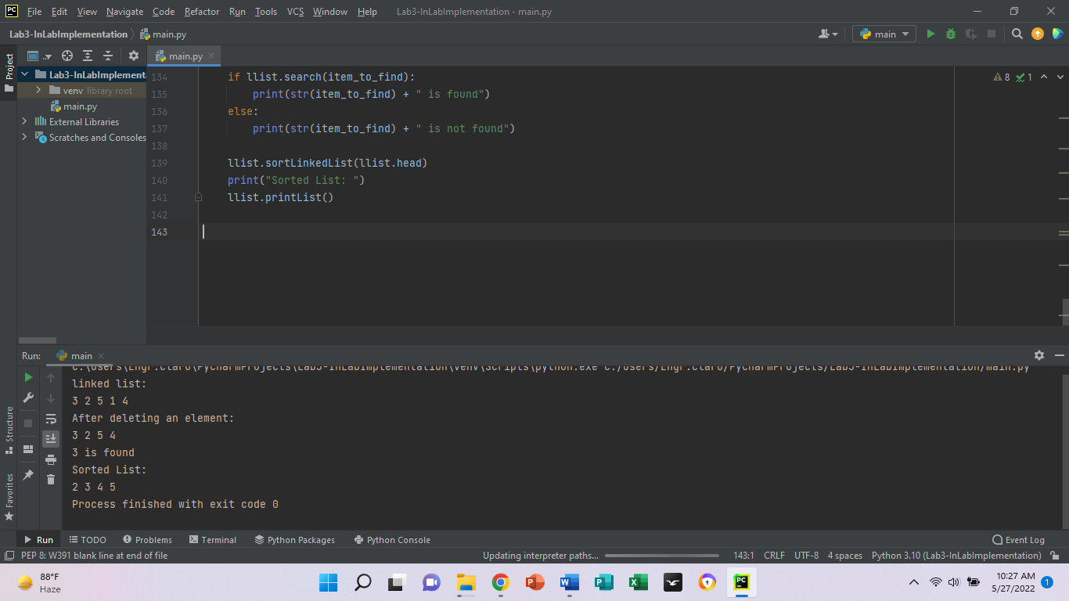

b.1)

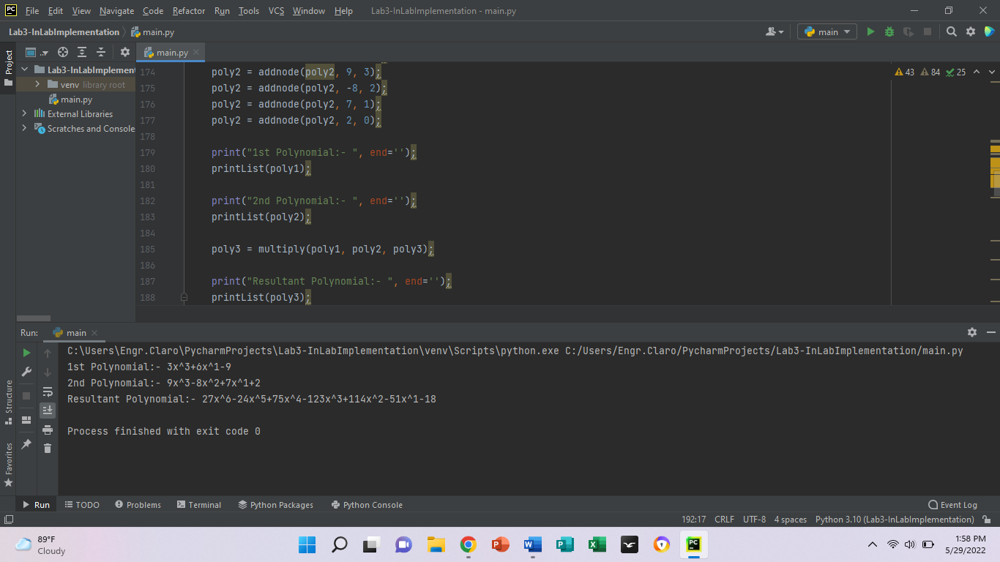

a.2)

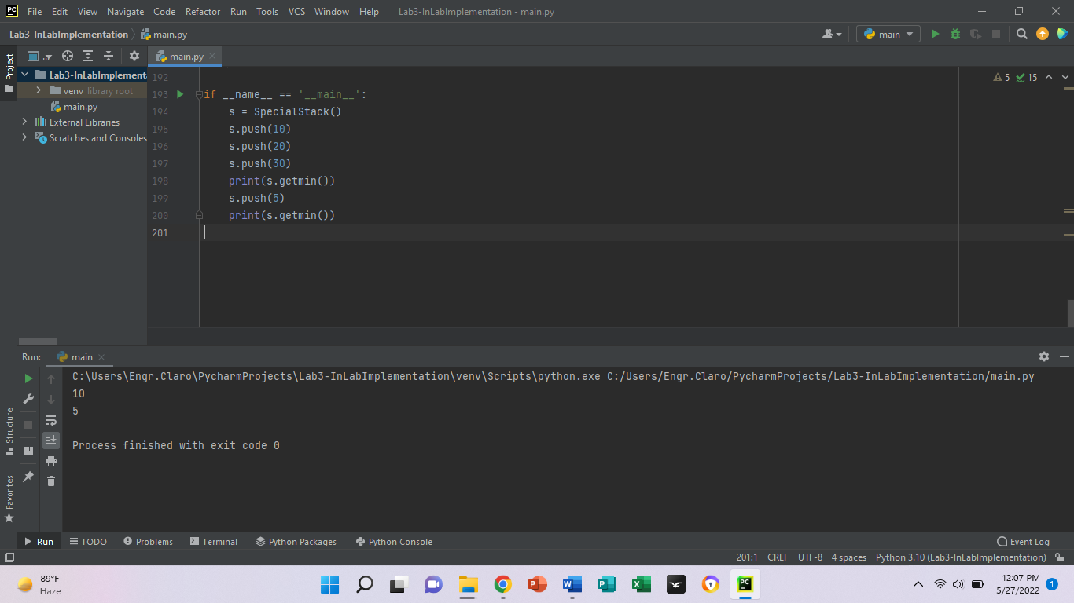

b.2)

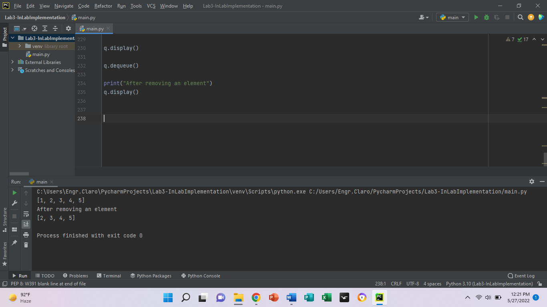

a.3)

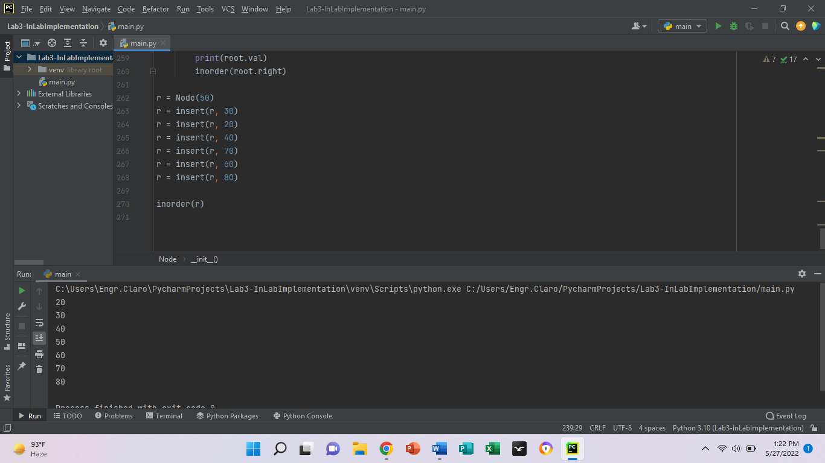

b.3)

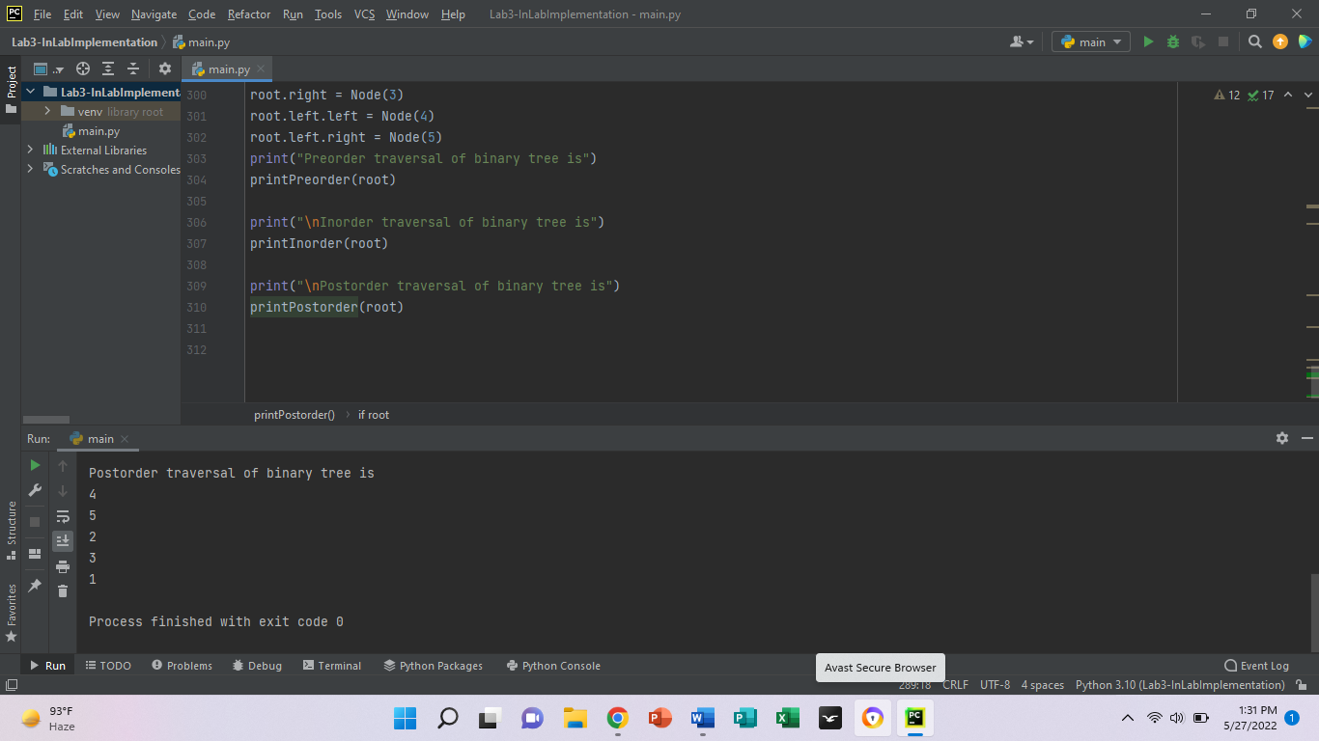

c.3)

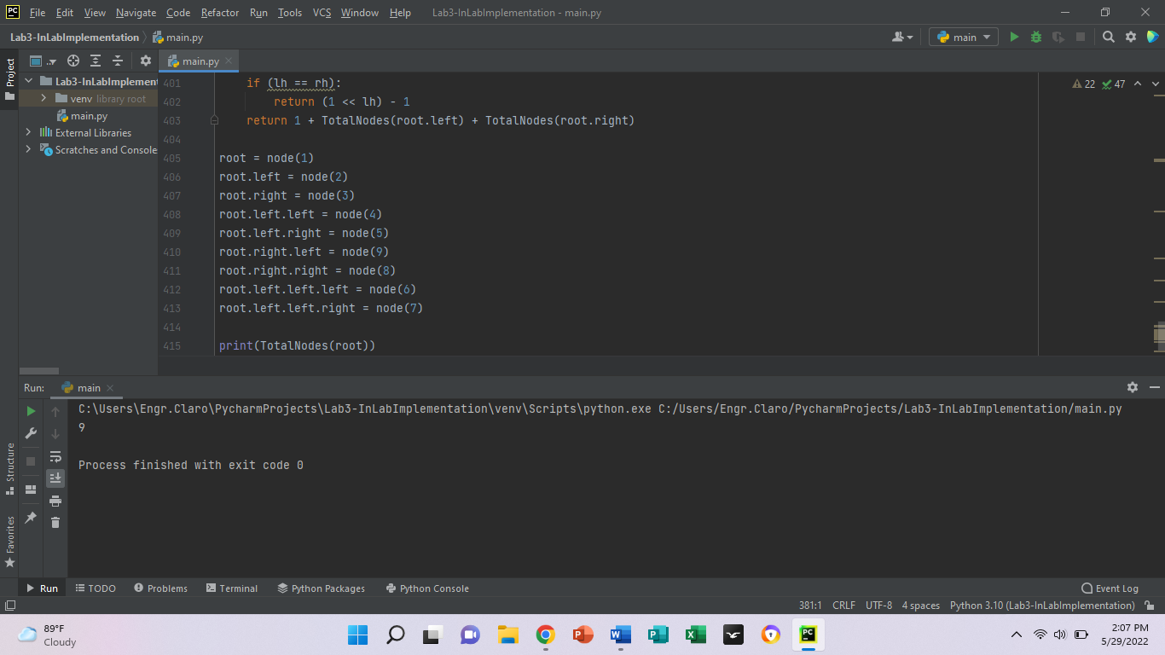

a.4)

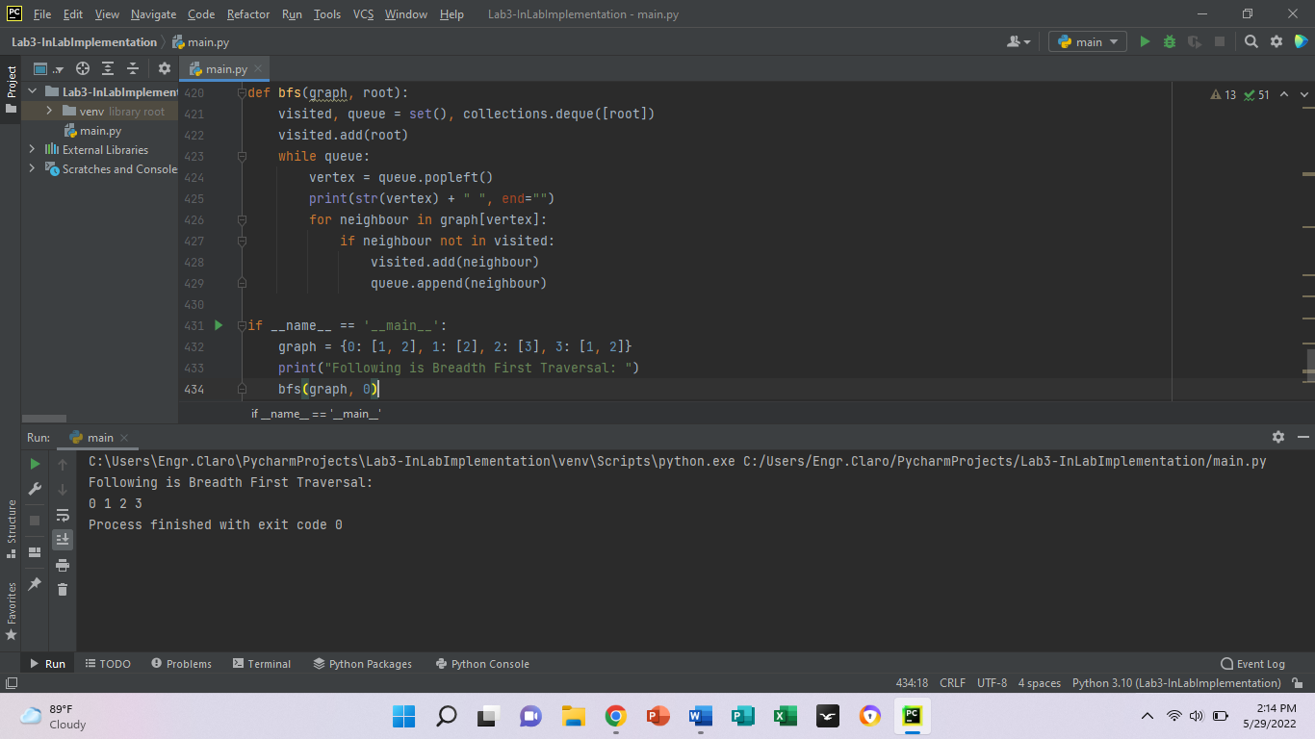

a.5)

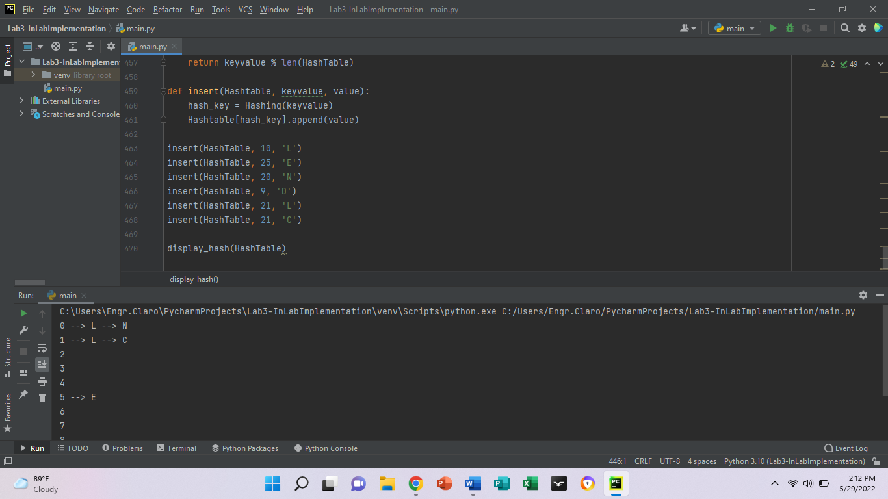

**Write your own Observation and Conclusion from what you have executed/read.**

The implementation of this InLab is for have the knowledge to use them in Python programming. A Singly Linked has nodes with a data field and a next link field. A Doubly Linked List has a previous link field along with a data field and a next link field. In a Singly Linked List, the traversal can only be done using the link of the next node. A circular doubly linked list is a mixture of a doubly linked list and a circular linked list. We used to work with data where only one direction or front and back data navigation is required, implement undo-redo features, construct most recently used and least recently used cache and construct different data structures such as hash tables, stacks and so on. Stacks are used in cache-based applications, like recently opened/used application will comes up. Queues are used in deleting/remove the data, like first inserted data needs to be deleted at first. Lastly the binary search tree is a data structure that allows for fast insertion, removal, and lookup of items while offering an efficient way to iterate them in sorted order.

**3. PostLab**

* **Project**

**Ref Lab3 Data Structures and Algorithms in Python Michael T. Goodrich,**

**Roberto Tamassia et.al: Chapter 7 Projects page 297**

**Do Projects P-7.44, P-7.45, P-7.46**

P-7.44 Write a simple text editor that stores and displays a string of characters using the positional list ADT, together with a cursor object that highlights a position in this string. A simple interface is to print the string and then to use a second line of output to underline the position of the cursor. Your editor should support the following operations:

• left: Move cursor left one character (do nothing if at beginning).

• right: Move cursor right one character (do nothing if at end).

• insert c: Insert the character c just after the cursor.

• delete: Delete the character just after the cursor (do nothing at end).

from tkinter import *  
  
app = Tk()  
  
def shift_cursor1(event=None):  
 position = entry_label.index(INSERT)  
 entry_label.icursor(position - 1)  
  
def shift_cursor2(event=None):  
 position = entry_label.index(INSERT)  
 entry_label.icursor(position + 1)  
  
button1 = Button(app, text="Shift cursor left", command=shift_cursor1)  
button1.grid(row=1, column=1, padx=10, pady=10)  
  
button2 = Button(app, text="Shift cursor right", command=shift_cursor2)  
button2.grid(row=1, column=0, padx=10, pady=10)  
  
entry_label = Entry(app)  
entry_label.grid(row=0, column=0, padx=10, pady=10)  
  
entry_label.focus()  
app.mainloop()

P-7.45 An array A is sparse if most of its entries are empty (i.e., None). A list L can be used to implement such an array efficiently. In particular, for each nonempty cell A[i], we can store an entry (i,e) in L, where e is the element stored at A[i]. This approach allows us to represent A using O(m) storage, where m is the number of nonempty entries in A. Provide such a SparseArray class that minimally supports methods getitem (j) and setitem (j, e) to provide standard indexing operations. Analyze the efficiency of these methods.

class SparseArray:  
 def __init__(self, A):  
 self._orig = A  
 self._storage = {}  
 for idx, elem in enumerate(A):  
 if elem != None:  
 self._storage[idx] = elem  
  
 def __len__(self):  
 return len(self._storage)  
  
 def __getitem__(j):  
 return self._storage[j]  
  
 def __setitem__(j, e):  
 self._storage[j] = e

sparse = [None] * 1000 + [1] + [None] * 1000 + [2]  
  
new_sparse = SparseArray(sparse)  
print(len(new_sparse))  
set_trace()

P-7.46 Although we have used a doubly linked list to implement the positional list ADT, it is possible to support the ADT with an array-based implementation. The key is to use the composition pattern and store a sequence of position items, where each item stores an element as well as that element’s current index in the array. Whenever an element’s place in the array is changed, the recorded index in the position must be updated to match. Given a complete class providing such an array-based implementation of the positional list ADT. What is the efficiency of the various operations?

class Node:  
 def __init__(self, data):  
 self.data = data  
 self.next = None  
  
class Stack:  
 def __init__(self):  
 self.head = None  
  
 def isempty(self):  
 if self.head == None:  
 return True  
 else:  
 return False  
  
 def push(self, data):  
 if self.head == None:  
 self.head = Node(data)  
 else:  
 newnode = Node(data)  
 newnode.next = self.head  
 self.head = newnode  
  
 def pop(self):  
 if self.isempty():  
 return None  
 else:  
 poppednode = self.head  
 self.head = self.head.next  
 poppednode.next = None  
 return poppednode.data  
  
 def peek(self):  
 if self.isempty():  
 return None  
 else:  
 return self.head.data  
  
 def display(self):  
 iternode = self.head  
 if self.isempty():  
 print("Stack Underflow")  
 else:  
 while (iternode != None):  
 print(iternode.data, "->", end=" ")  
 iternode = iternode.next  
 return  
  
MyStack = Stack()  
MyStack.push(11)  
MyStack.push(22)  
MyStack.push(33)  
MyStack.push(44)  
MyStack.display()  
  
print("\nTop element is ", MyStack.peek())  
  
MyStack.pop()  
MyStack.pop()  
MyStack.display()  
  
print("\nTop element is ", MyStack.peek())

* **Debugging and Sample Run** (with screenshots and Discussion)

P-7.44)

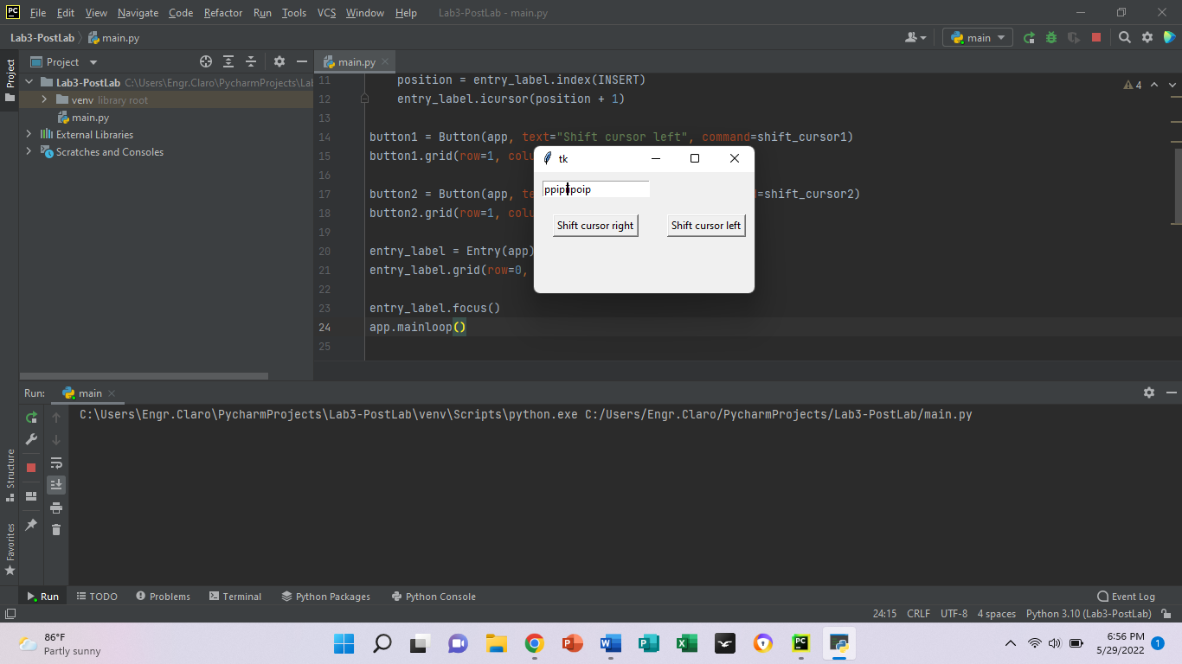

P-7.45)

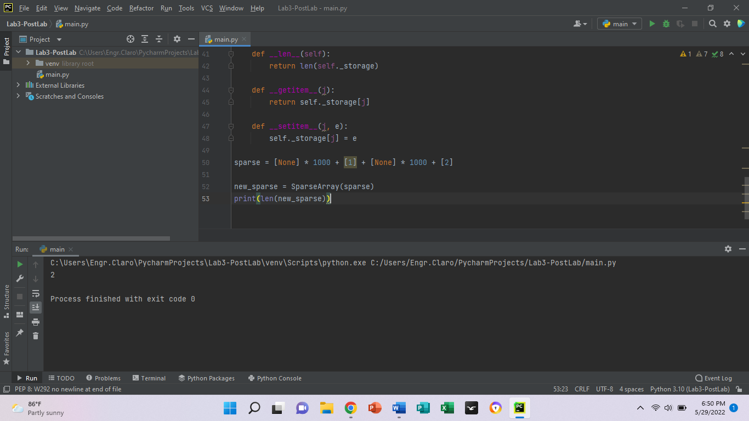

P-7.46)

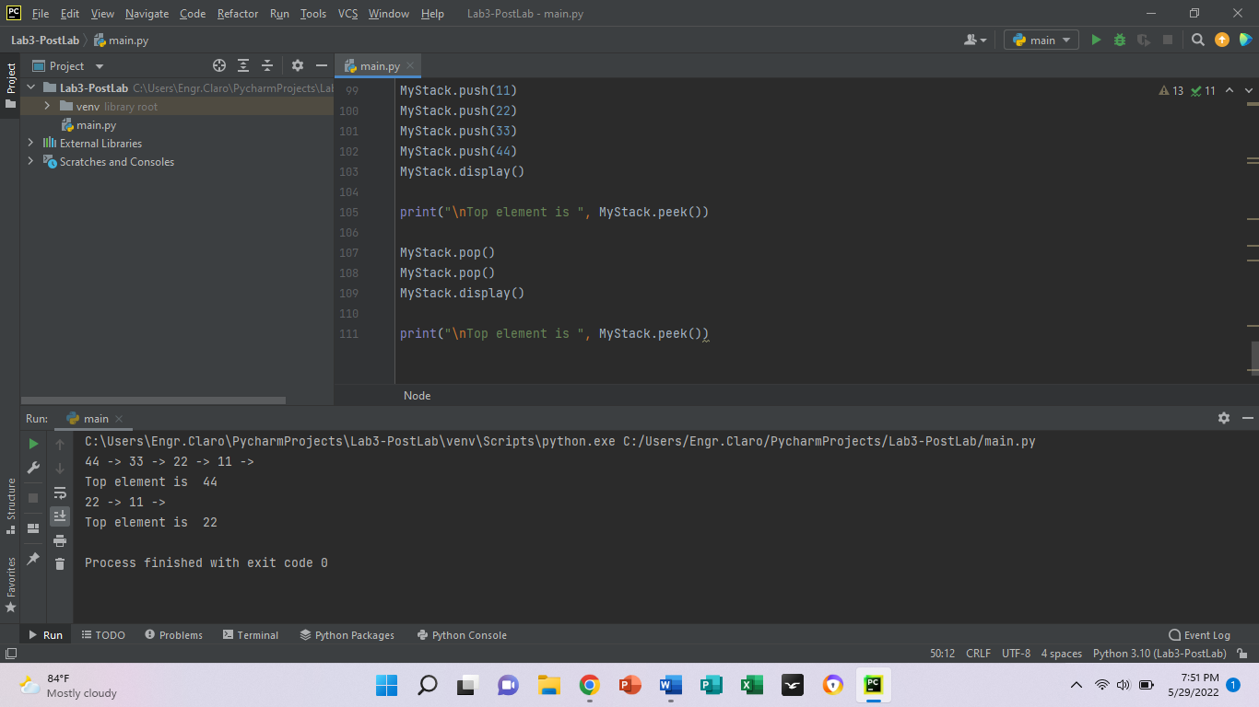

**Write your own Observation and Conclusion from what you have executed/read.**

ADT are used in the design and analysis of algorithms, data structures, and software systems, and do not correspond to specific features of computer languages. We used a linear data structure in which we can push, add, insertion and deletion and so on, that the operations are performed at two different ends. The array is a basic [abstract data type](https://brilliant.org/wiki/abstract-data-types/) that holds an ordered collection of items accessible by an integer index. These items can be anything from primitive types such as integers to more complex types like instances of classes.